
Rosary School / Marj El Hamam
Name : _____________________ Date : / 2 / 2025
Subject :Science Grade: 6 ( )
Study Sheet
7G The Particle Model

7Ga Solids, liquids, and gases + 7Gb Particles
The different properties of solids, liquids and gases can be explained by the particle model. These three states of matter are handled and stored differently because of their different properties.

The theory that is used to explain the different properties of solids, liquids, and gases is called the particle theory or particle model of matter. It states that:
- all matter is made up of tiny particles.
- the particles are moving all the time.
- there are forces of attraction holding the particles together.
- the forces vary in strength in the different states of matter.

The volume of an object is the amount of space that it takes up. It can be measured in cubic centimetres (cm³).
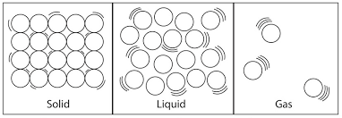
Solids ● Solids are made up of particles that are very close together (held by strong forces of attraction). ● The particles can’t move over each other, but vibrate in fixed positions (back & forth). ● The shape of solids do not change. ● Solids do not flow.
The volume of a solid does not change much and so ,even when squeezed, solids cannot easily be compressed (squashed into a smaller volume).

Liquids ● Liquids are made up of particles that are fairly close together (held by fairly strong forces of attraction). ● The particles in liquids can move past each other. ● Liquids have a fixed volumes but their shape can change to fit the container as they flow easily. ● Liquids cannot be easily compressed (squashed).

Gases ● The particles in gases are far apart from each other. ● The forces of attraction between the particles are weak, so the particles in gases move about freely in all directions. ● The shape and the volume of gases can change as they flow very easily and spread out. ● Gases can be compressed (squashed) easily into a small volume.

Density
Density is the mass of a certain volume of material. It is measured in units such as kilograms per cubic metre (kg/m³) or grams per cubic centimetre (g/cm³).

- Iron is denser than water, which has a density of 1 g/cm³. 1 cm³ of iron is much heavier than 1 cm³ of water. In general, solids are denser than liquids and liquids are denser than gases. The density of gases can be changed by squashing them.

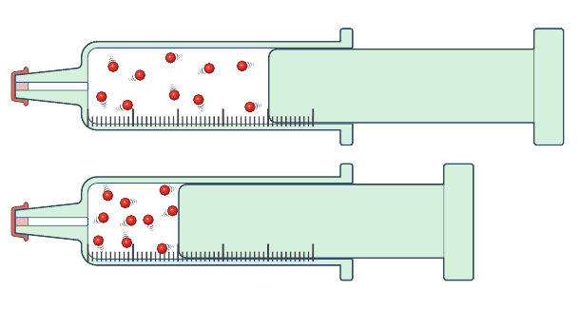
- Note: when we compress a gas density increases, volume decreases and the mass stays the same.

Questions: Workbook page 76

Using the theory
- Solids have a fixed shape, as the particles are held closely together by strong forces of attraction.

- Solids cannot be compressed because the particles are very close together.

- Liquids can flow and change their shape, because although the particles are close together they can move over each other.

- Liquids cannot be compressed because the particles are very close together.

- When soluble solids dissolve in liquids, the tiny solid particles are separated from one another and spread through the liquid. Since the solute particles are so spread out, you can then see through the solution.

- Gases have no fixed shape or volume, as their particles are free to move in all directions. This allows gases to spread out and fill all the space in a container.

- Gases are fairly easy to compress because their particles are far apart.

Questions:
- Main book questions ( 5, 6 & 7 ) page 107
- Workbook pages 79 & 80
7Gc Brownian motion:

- It is the jerky random movement of small particles (dust, pollen grains or smoke speck) in different directions in a liquid or gas.
The movement occurs because of particles colliding with each other in a liquid or a gas.
It can be seen:
- when pollen grains in water are observed through a microscope they are seen to move jerkily in different directions. This is called Brownian motion. It is caused by water particles, which are moving all the time, hitting the pollen grains. The pollen grains are small enough so that when many water particles hit one side of the grain, the grain is moved in that direction.

- with specks of smoke in the air.

- with fine dust in liquids other than water.
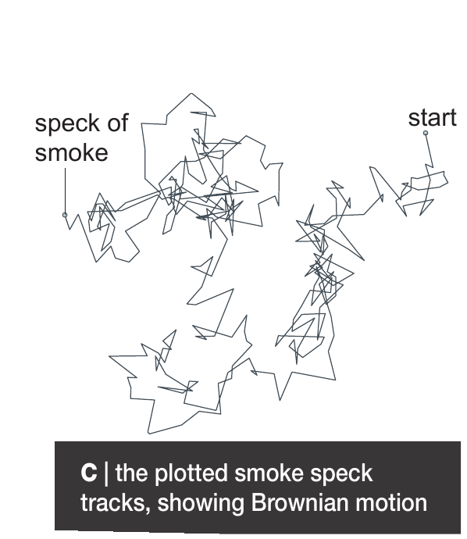
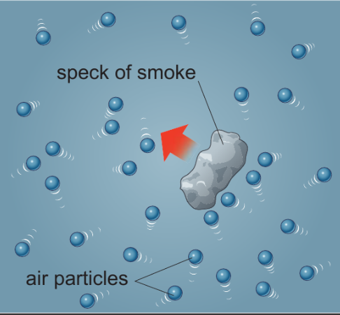

*Explanation using particle theory:
-The particle model says that air consists of tiny particles, moving about in all directions. Air particles therefore hit specks of smoke. If many particles hit one side of a smoke speck, they push the speck in that direction. However, the air particles are moving about randomly and so the direction in which a smoke speck is pushed will change all the time. We therefore see Brownian motion as random movements.

The Nanoscale:
- When dealing with such small particles, we use nanometers as the unit of measurement:
1 nanometre (nm) is 0,000 000 001 metres (m).
Questions:
- How many nanometer are in 0.3 meters?
_______________________________________________________________
_______________________________________________________________

- How many meters are in 22000000 nm?

______________________________________________________________

______________________________________________________________

3.
- Main book questions ( 1 & 5 ) pages 108 & 109
- Workbook page 81

7Gd Diffusion:

When particles of one substance spread out and mix with the particles of another from high concentration to low concentration, we call this diffusion.
Diffusion is fastest in gases, and slower in liquids.
Diffusion occurs because particles in a substance are always moving around. So there is an overall movement of particles from where they are in greater concentration (more particles in a certain volume) to where they are in lower concentration.
Diffusion is an important process inside our bodies. Diffusion allows particles of essential substances in our food to pass through the wall of the small intestine and into the blood. The blood then carries them around our bodies, where they diffuse into the cells of the body. Waste products are also removed by diffusion.

Questions:
1) Give one example of diffusion in everyday life.
___________________________________________________________________
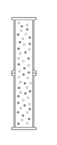
- Explain how diffusion occur in gases.
____________________________________________________________
____________________________________________________________
____________________________________________________________
____________________________________________________________
- Why diffusion is faster in gases than liquids?

__________________________________________________________________________
__________________________________________________________________________

4)
- Main book questions (2, 3, 5 &7 ) pages 110 & 111
- Workbook page 82

7Ge Air pressure:
Air pressure is just the force of air particles hitting a surface.
Pressure is caused by particles hitting the walls of the container they are in. It increases when:
1. the container is squashed (the volume is smaller so particles hit the walls more often)
2. the number of particles is increased (there are more particles moving around to hit the walls).

If the particles are in a flexible container, like a balloon, an increase in pressure inside the container can make the volume increase. If the pressure becomes too great, the balloon will burst.
Gas pressure inside a car tyre, pushing out, keeps the tyre inflated. The more particles that hit a certain area of a surface, the greater the gas pressure. Adding more air particles into a tyre will increase the gas pressure inside it. Squashing the tyre to make its volume smaller will also increase the gas pressure.

Air pressure is a type of gas pressure and is caused by air particles around us.
If there is no gas in a container, you get a vacuum (nothingness).

Air pressure lets us:
- suck up liquids through a straw works because of air pressure. When you suck, you reduce the pressure inside the straw. So the air pressure outside the straw is greater than the pressure inside the straw and the liquid is pushed up the straw.

- causes a container to collapse if air is sucked out, because the air pressure outside the container is greater than the pressure inside.

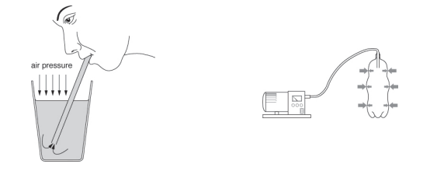

Questions
- Main book questions (3, 6 & 7) page 113
- Workbook questions pages 83 & 84

