

Rosary School – Marj Elhamam
7I - Study sheet
Name: _________________ |  | Date: / / 2025
Grade: 6 (A,B,C,D,E)
7I Energy and Changes
7Ia Energy from food
Humans and other animals need energy to live. The energy resource for our bodies is the energy stored in food. Energy is needed to help us:
- to grow and repair our bodies
- to move and keep warm
Different people need different amounts of energy depending on their age, gender and physical activity.

- We need to choose our food so that we get the right amount of energy to get good diet.
If the diet contains more energy than the person needs, the body will store the energy in fat and the person will gain weight. If the diet contains less energy than the person needs, the person will lose weight and become thinner.
- A good balanced diet provides all the nutrients that the body needs for health, and includes a mixture of different foods.
The unit for measuring energy is the joule (J). There is a lot of energy stored in food, so we usually measure the energy in food using kilojoules (kJ). 1 kJ = 1000 J.

Questions:
- Copybook (External Questions Examples )
- Workbook page100

7Ib Energy transfers and stores
Energy can be transferred by:
● heating
● light
● sound
● electricity
● forces.
Energy can also be stored in different ways.
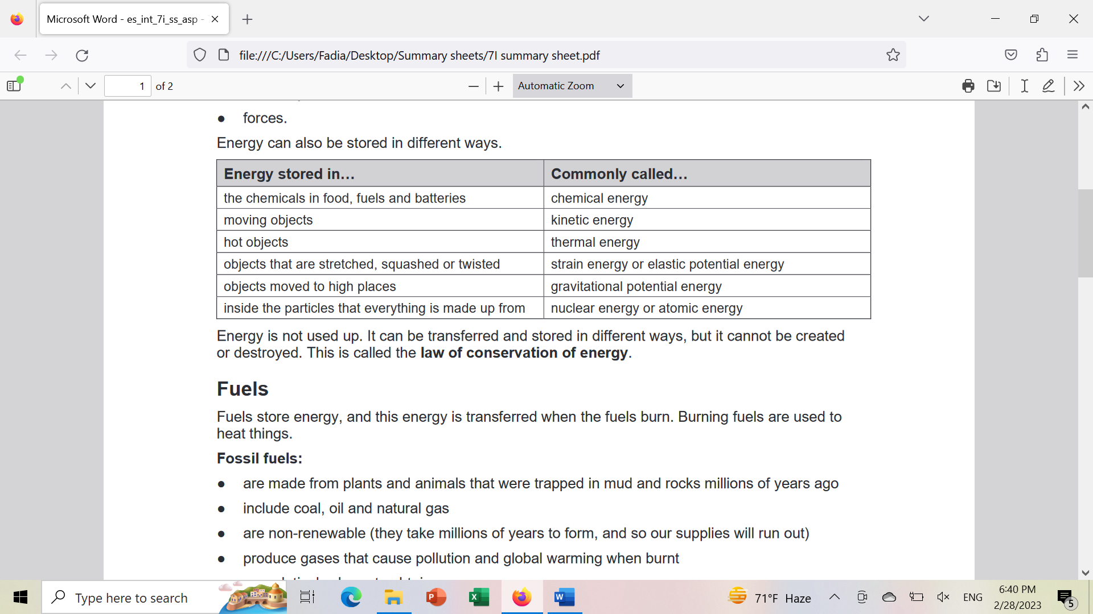
Energy is not used up.it cannot be created or destroyed; It can only be transferred and stored in different ways. This is called the law of conservation of energy.

Questions
- Workbook pages 102 & 103

7Ic Fuels:
Fuels store energy, and this energy is transferred when the fuels burn. Burning fuels are used to heat things.
Fossil fuels (oil, natural gas and coal)
- are non-renewable (they take millions of years to form, and so our supplies will run out, so they cannot be replaced at the rate that humans use them up).
- originally got their energy from the Sun. The plants that became coal, oil and natural gas got their energy from the Sun, and the animals that became oil and natural gas got their energy from plants, which got their energy from the Sun.
Oil and natural gas:
● are made from tiny plants and animals that were trapped in mud and rocks millions of years ago. More layers of mud squashed them, turning them into crude oil and natural gas.
- Fuels such as petrol and diesel are made from oil.
Coal:
- Was formed many millions of years ago from plants.
- When the plants died they became buried in mud, which stopped them from rotting away.
- More layers of the mud squashed the plant remains with the presence of heat from inside the Earth, turned the mud into rock and the plant remains into coal.
Biofuels:
- are made from plants or the wastes from animals.
- They are renewable fuels, because plants can be grown to make more fuel.
Nuclear fuel:
- is also non-renewable.
- Nuclear power stations produce dangerous waste materials such as uranium.
Notes:1) Electricity is not a fuel. It has to be generated using other energy resources.
2) Gases such as hydrogen can be also used as fuel. Hydrogen is made from natural gas, but scientists are trying to find ways of making it cheaply from water.

Questions
- Workbook pages 104 & 105
- Question 4 on page 141 in the main book.

7Id Other energy resources:
Biofuels are used in vehicles, heating, cooking or generating electricity.
Renewable energy resources include: solar, tidal, wave, biofuels, geothermal and hydroelectricity.

- Solar power uses energy transferred from the Sun.( solar panels and solar cells)
  - Solar panels: It’s used for heating the buildings and to provide hot water for washing.
  - Solar cells: Using energy transferred by light to produce electricity directly.

- Wind turbines use the wind to turn large blades and the blades turn a generator.

- Hydroelectric power ( waves and tides can also be used to generate electricity
- Geothermal power (rocks under the ground are hot. Water can be heated by pumping it through the rocks)

Nucleur Energy from the Sun:
Most of the energy resources we use store energy that originally came from the Sun.
Only geothermal power, nuclear power and tidal power do not depend on energy from the Sun.
How energy is transferred to our food:
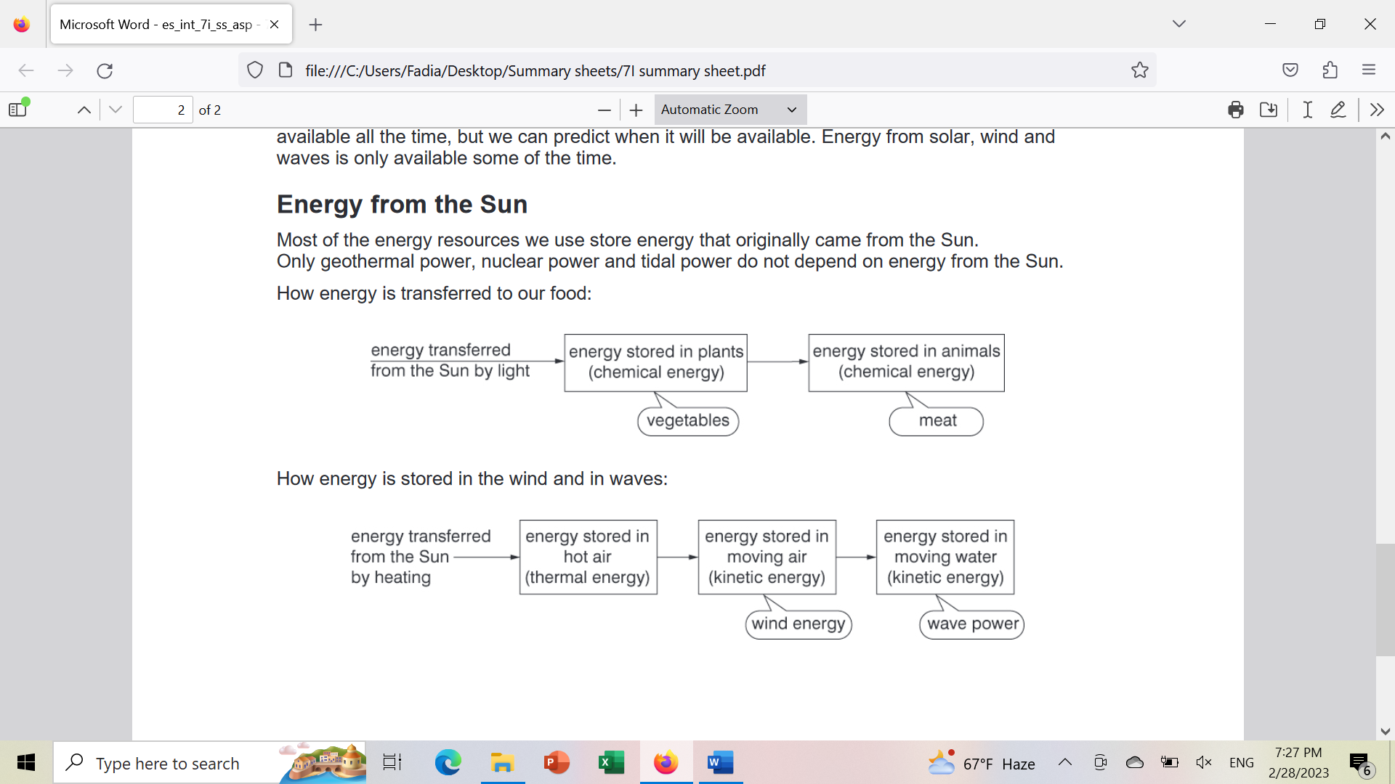

How energy is stored in the wind and in waves:
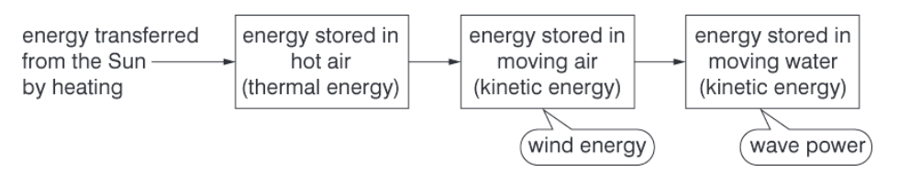
Notes:
- Most renewable resources are not available all of the time, because they depend on the weather.
- Only hydroelectricity and geothermal energy and biofuels are available at any time; however, these resources can only be used in certain locations with a suitable place for a reservoir or hot rocks underground.

Questions
- Question 6 on page 145 in the main book
- Workbook pages 107 & 108
7Ie Using Resources:
Energy resource | Advantages | Disadvantages
fossil fuel  (used to generate electricity, to power transport and for heating) | - cheap compared with other resources  - convenient to use in cars and other vehicles | - release polluting gases when they burn  - non-renewable
Nucleur  (used to generate electricity) | - no polluting gases | - power stations are very expensive  - produces dangerous waste materials  - Non-renewable
Renewable resources  (mainly used to generate electricity) | - no polluting gases  - renewable | - most are not available all of the time

Making fossil fuels last longer:
- Wear a jumper instead of keeping the house very warm in winter.
- Walk, cycle or use public transport instead of using a car.
- Use efficient appliances when you can.
- Insulate homes so that less energy escapes by heating, or is needed for cooling.

Efficiency: Is a way of saying how much of the energy transferred by a machine is useful.
An efficient machine does not waste much energy. This means that less fuel will be burnt to produce electricity to run it, so the electricity bills will also be cheaper.
- Diagram E page 147 in the main book
:
energy stored in the carriages as they get higher (gravitational potential energy)
useful energy transferred
energy transferred to
the ride by electricity
energy stored in the motor and surroundings which get warmer (thermal energy)
wasted energy transferred

Questions
- Workbook page 109

