
Rosary School / Marj El Hamam
Name : _____________________ Date : / / 2025
Subject :Science Grade: 6 ( )
Study Sheet
7K Forces
7Ka Different forces:
Forces are pushes or pulls.
Forces can:
● change the shape or size of an object
● change the speed things are moving (make them move faster or slower)
● change the direction of a moving object.

Solid things, like your chair, push up on you when you sit on them. Upwards forces from water or air are called upthrust. Things float in water because of upthrust.
-Contact forces: only act when two objects or materials are touching.
Examples of contact forces are:
● friction: is a force caused by two things rubbing together.
● air resistance (kind of friction)
● water resistance (kind of friction)
● upthrust.
-Non-contact forces: forces that can affect objects from a distance (without touching)
Examples on non-contact forces:
● magnetism ● gravity ● static electricity.

The unit for measuring force is the newton (N).
- The direction in which the force is acting is important so we use arrows to show forces.
- The direction of the arrow shows the direction of the force,
- The bigger the arrow the bigger the force.

Weight and mass
- Your mass is the amount of substance in your body. Your mass is measured in kilograms (kg).
- Your weight is a force caused by gravity pulling on your body. The newton (N) is the scientific unit used to measure forces, and so it is also used as the unit for weight.
Wherever you take an object, its mass will not change but its weight depends on the force of gravity. An object on the Moon would have a smaller weight than on Earth, because the Moon’s gravity is not as strong as Earth’s.

Questions:
- Workbook page124 + 125

7Kb Springs:
- Materials and objects can be stretched (made longer) or compressed (made shorter).
- The amount of stretch or compress depends on the type of the material and the size of the force.
- Elastic materials will stretch with a force and then return to their original shape when the force is taken away.
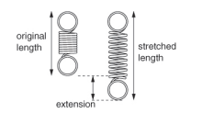
- Springs are elastic as they are made from coils of wire.
- The extension of a spring is the difference between its original length and its stretched length.
The apparatus bellow is being used to investigate the extention of a spring
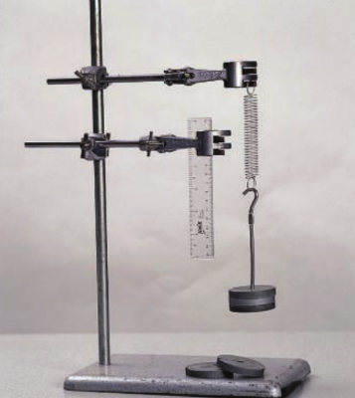

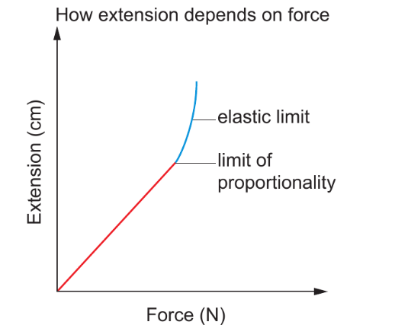
The graph shows that extension is proportional to the force up to a certain point, called the limit of proportionality. This means that for every 1N increase in the force, the spring stretches by the same amount.

*Hook’s law: The extension is proportional to the force.

If the spring is stretched too far, the extension stops being proportional to the force. If it is stretched even further, it goes beyond its elastic limit. The spring will no longer return to its original length when the force is removed.

- Materials that do not return to their original shape when a force is removed are plastic materials.

- Force meters have springs inside them. If the meter is measuring a small force, the spring inside only stretches a little away. If it’s measuring a bigger force, the spring stretches further and the pointer moves further along the scale.

Questions:
- Workbook page 126.

7Kc Friction:
Friction is a contact force (between two touching objects)
Friction can:
● slow things down ● produce heat
● wear things away ● cause a noise
Friction can be increased by using rough surfaces, or by using materials such as rubber that have a lot of friction.
Friction is helpful in:
- the tyres of a Formula One racing car as it stops the car from sliding off the road as it speeds round sharp corners.
- Rock climbing shoes as they are made from special rubber that increases friction to give a good grip.
- Abseiling as it helps the abseilers to control how fast they go down the cliff.

Friction can be reduced by using smooth surfaces, or by lubrication. Oil and grease are examples of lubricants, and help things to move past each other easily.
Friction is not helpful in:
- The brake pads on a bicycle eventually wear away and so do car tyres.
- Part of your clothes get thinner as friction wears them away.
- If a car engine runs without any oil in it, the large amount of friction between the moving parts causes it to overheat and stop working.
- Rusty door hinges squeak and make doors difficult to open.

*Note:
Friction due to gases (air resistant) and liquids (water resistant) can also cause things to slow down. And it can be reduced by having smooth surfaces and smooth shapes.

Questions
- Workbook pages 127.

7Kd Pressure:
Pressure is the amount of force pushing on a certain area.
- The size of the pressure depends on the size of the force and the size of the area it is pushed on.
      - For a certain area, the bigger the force, the bigger the pressure. For a certain force, the bigger the area, the smaller the pressure.

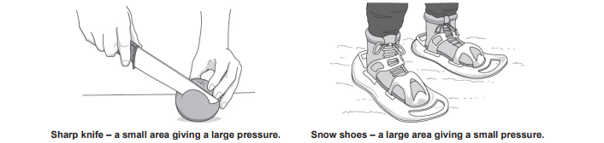

      - We use this formula to calculate pressure:

Pressure= force÷ area
Force is measured in newtons (N) and area is measured in square meters (m²).
So the unit of pressure is( N/m²) wgich is also capped pascal (P).

Questions
- Workbook pages 128

7Ie Balance and unbalanced:
- Balanced forces: forces on an object that are the same size but work in opposite directions.
If forces are balanced:

● a stationary object stays stationary

● a moving object continues to move at the same speed and in the same direction.

- Unbalanced forces: forces on an object are not the same size (one force is stronger than the other) but work in opposite directions.
If forces are unbalanced:
● a stationary object will start to move.
● a moving object will change its speed or direction.

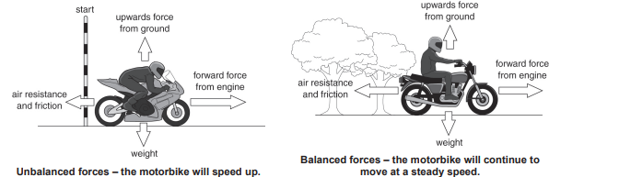

- How force meter works?
When you stretch a spring it gets harder and harder to pull it because the spring pulls back.

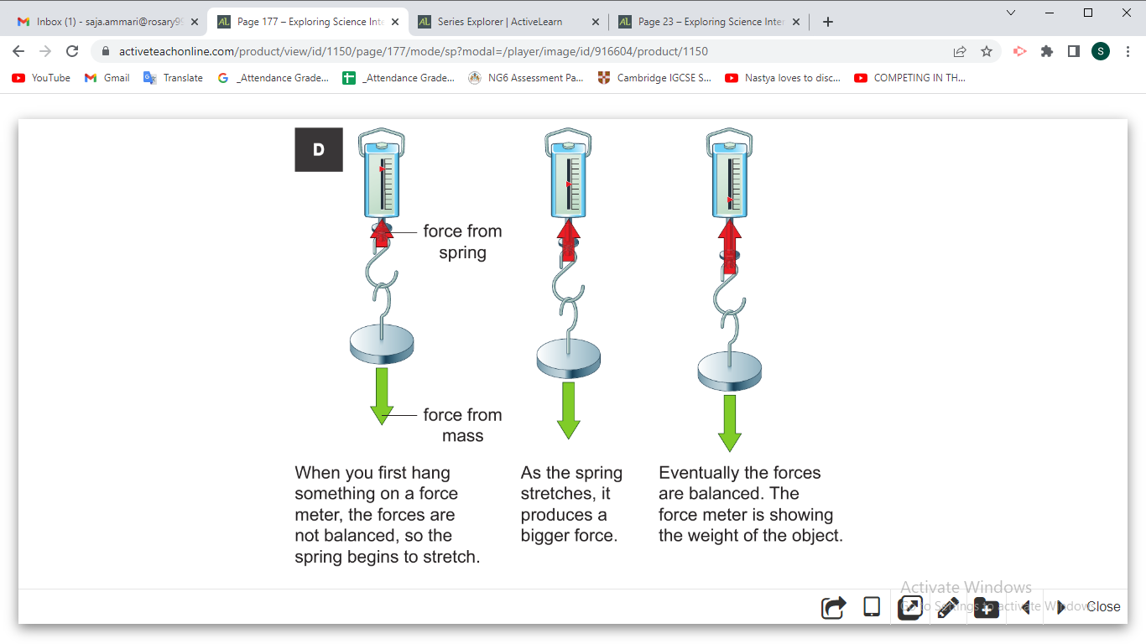

Questions
- Workbook pages 131+132

