

Rosary School / Marj El Hamam
7L - Study Sheet
Name : _____________________ Grade 7: A, B, C, D,E
Subject : Physics (Study sheet 1)
7L Sound
7La Moving sounds
- Sound is a way of transferring energy. Sounds are made when things vibrate.
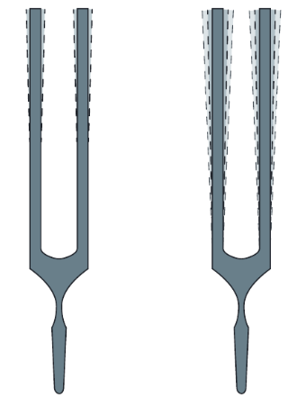
- The vibrations are passed on by particles. Sound therefore needs a medium (substance) to pass on the vibrations, so it can travel through solids, liquids and gases but not through empty space (vacuum).

Loudness (intensity)
It describes how loud or soft the sound is. It depends on the size of vibration (amplitude).
- The amplitude of a wave is how far the particles move as the vibrations pass. The larger the amplitude, the louder the sound.
If you tap the tuning fork on the right hard, it makes a loud sound. If you tap it gently, it makes a soft (quiet) sound.
- The loudness of a sound is measured using a sound intensity meter. The units are decibels (dB).
The loudness of a sound depends on how big the vibration of the source of sound and air is.
- If air particles move back and forth a lot, we hear a loud sound.
- If the source of a sound makes the particles vibrate more gently, we hear a softer (quieter) sound.

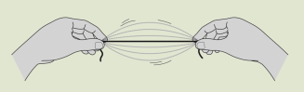
Pitch and frequency
Pitch of a sound is how high or low a sound is. It depends on the speed of the vibrations (frequency).
The more stretched a rubber band is, the quicker it vibrates and the higher the pitch of the sound.

The pitch of a sound depends on how quickly the source of sound and air vibrate.
- When air particles move back and forth quickly we hear a high pitch sound.
- When the air vibrates less quickly we hear a low pitch sound.
Note: Smaller, shorter, thinner and tighter objects vibrate faster so they produce high pitched sounds. While bigger, longer, looser and thicker objects vibrate slower producing lower pitched sounds.
- Frequency is the number of vibrations (complete vibrations) passing each second. The units of frequency are hertz (Hz).
$$Frequency (Hz)= \frac{number of vibrtions (complete waves)}{time (seconds)}$$
Example:
A giant hummingbird flaps its wings about 720 per minute. Calculate the frequency.

- Workbook pages 136

7Lb Moving sounds + 7Le Comparing waves
How do sounds move through materials?
- When sound is produced, for example from a vibrating loudspeaker, air particles close by will be pushed and start to vibrate backwards and forwards.
- The vibrating air particles will start to push on the air particles next to them, so the vibrations are passed on and spread out through the air.
- Although the particle moves back and forth, it doesn't actually go anywhere, it just passes the movement on. The moving vibrations form a sound wave.
- The particles in a sound wave are squashed in some places (high pressure) and spread out in other places (low pressure). This is why sound wave are called pressure waves.

Types of waves:
  - Longitudinal waves:
- Sound is an example of a longitudinal wave because the particles vibrate in the same direction as the wave (energy) travels.
- The amplitude of a longitudinal wave is the maximum change in the position of a particle from its starting position.
- Pressure waves (sound waves) transfer energy from one place to another. They don’t transfer particles. The louder the sound, the more energy it is transferring.

- Workbook pages 137
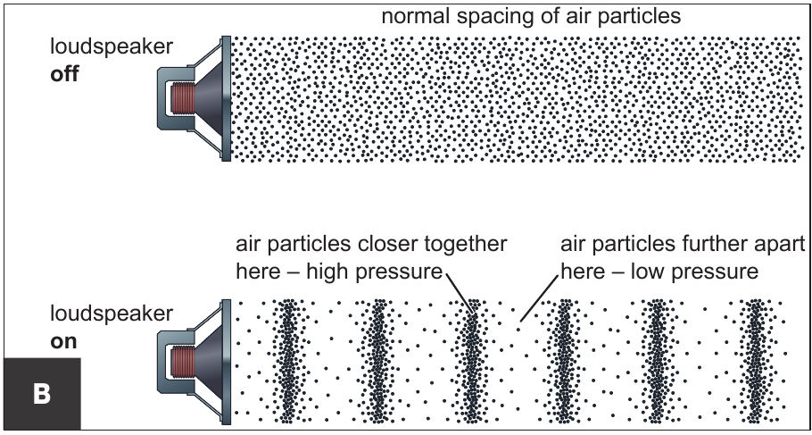
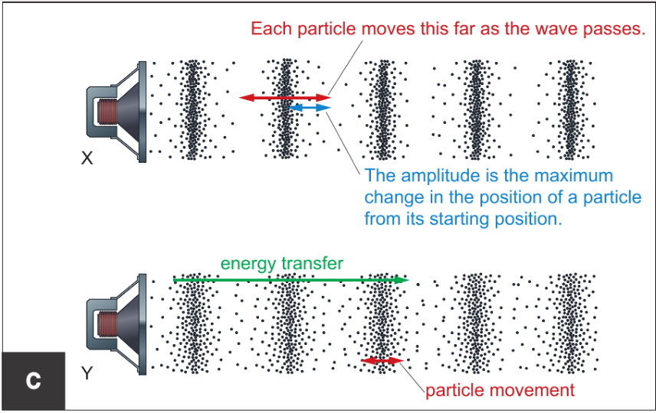

  - Transverse waves:
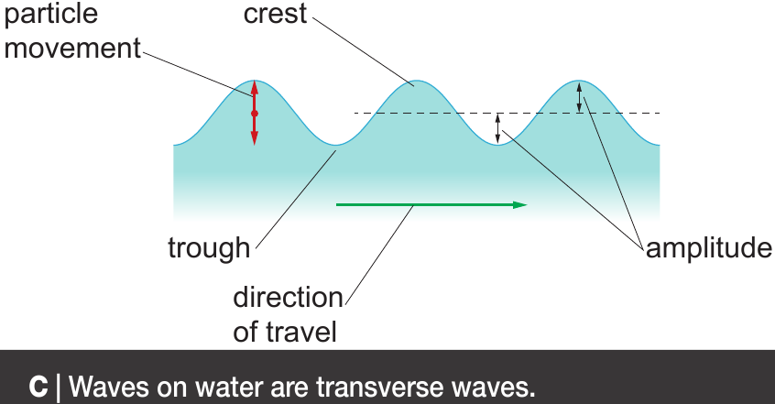

- Waves on the surface of a water are transverse waves.
- In a transverse wave the particles vibrate or move up and down at right angles to the direction the wave (energy) is travelling.
- The amplitude of a transverse wave is the maximum distance the particles move up or down from their original position.
- The amplitude of a waves on water gets smaller as the waves get further from their source because the energy transferred by the wave gets more spread out.
- Waves on water can be reflected when they hit a solid barrier.
- Waves going in different directions can pass through each other. Their effects can either add together or cancel out in a process called superposition.

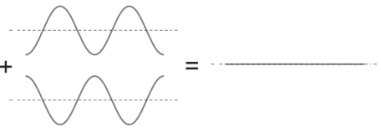
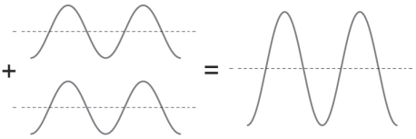


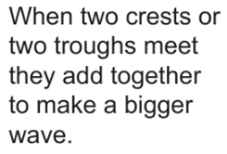

- Workbook pages 145
Speed of sound
- The speed of sound is usually faster through materials in which particles are closer together. Closer particles hit each other more easily and so the energy is more likely to be passed from one particle to the next.
- Sound travels faster in solids than in liquids, and it travels slowest in gases.
- Sound waves spread out from a source. As you get further from the source, the energy carried by the sound wave has spread further.
- The further you are from the source the less the energy that it is there for your ears to detect.
7Lc Detecting sounds
- Sound is detected by ears and microphones.
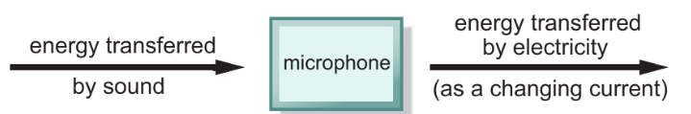
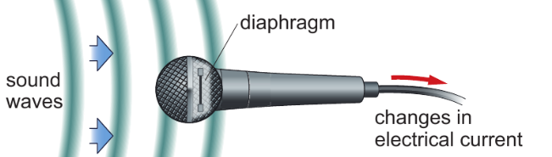
Energy transfers changes in a microphone.

In a microphone, sound waves make a diaphragm vibrate, and electronics are used to convert the vibrations into changes in an electrical current.

- Ears work in a similar way:
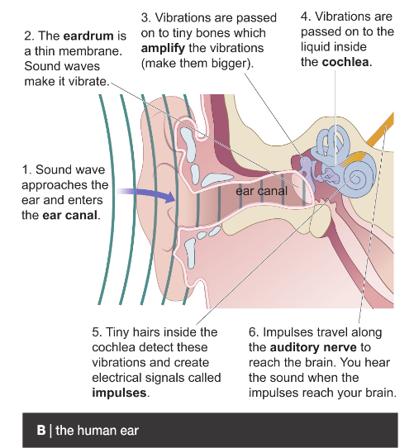
- Loud sounds can damage our ears. We often need to wear ear protection made of certain materials to absorb some of the energy transferred by sound waves. In our homes soft materials like carpets and curtains help to absorb sounds.
Hearing ranges
- The auditory range of an animal is the range of frequencies of sound it can hear. Animals such as bats and dolphins can hear ultrasounds (sounds with frequencies greater than 20 000 Hz). Some animals can hear infrasounds (frequencies less than 20 Hz).
- The human auditory range is between 20Hz to 20000Hz.
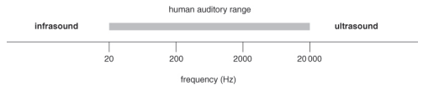
- Workbook pages 141,142

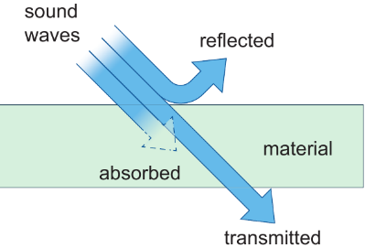
7Ld Using sound:
Sound waves transfer energy from one place to another. The energy transferred by sound waves is transmitted through some materials, or it can be absorbed or reflected.
- Humans and other animals use sound for communication.
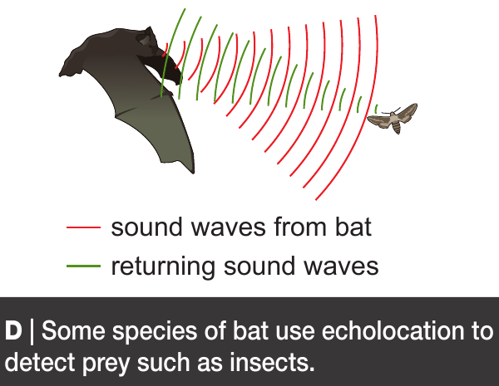
- Some animals, such as bats and dolphins, use ultrasound to locate prey and avoid obstacles. These animals produce bursts of ultrasound and listen for the sound waves reflected by objects or prey. They detect how far the object is by the time it takes the echo to return.

- Humans use ultrasound in sonar, to find the depth of the sea or locate fish or submarines.

- Humans use the energy transferred by ultrasound to clean delicate objects (such as jewelry) or in physiotherapy (to relieve pain or aid healing).
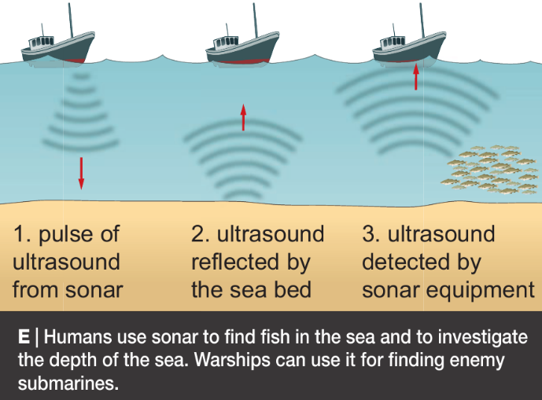
- Workbook pages 143

- An oscilloscope is an instrument that shows a picture of a sound on screen.
- An oscilloscope can be connected to a microphone to show sound waves. The oscilloscope trace is like a line graph.
- The trace is the line that appears on the screen that represents the sound wave.
- On a sound wave trace, the amplitude is the maximum distance from 0.
- The frequency is the number of complete waves (one up and down) that pass a poiy each second.
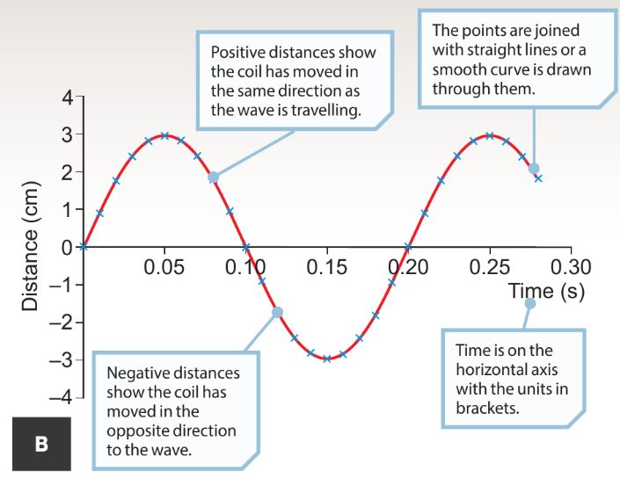
- In trace B, one wave takes 0.2 seconds. In each second 5 waves pass and so the frequency is 5 Hz.

- Workbook page 139 Q.3

