

Rosary School – Marj Elhamam
7B - Worksheet 2
Name: _________________ |  | Date: / / 2025
Grade: 6 (A,B,C,D,E) |  | science
Question 1:
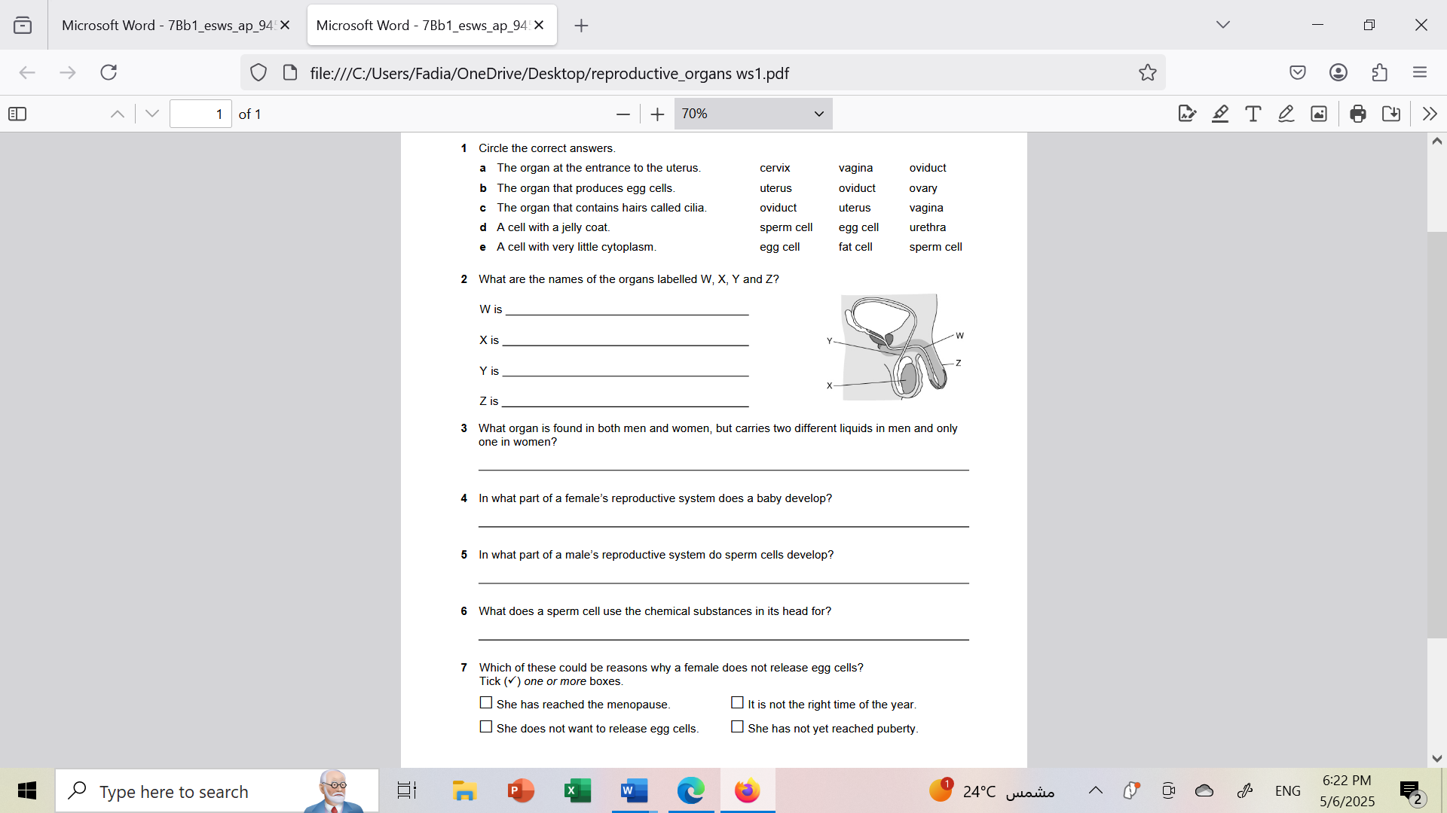
Question 2 :
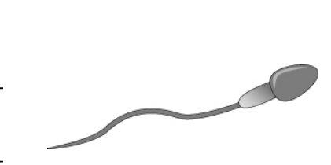
The drawing shows a gamete.
- Is this gamete produced by male or female?___________________________________
- In which organs is it produced?______________________________________________
- Mention three adaptations does the gamete have.
________________________________________________________________________________________________________________________________________________________________________________________________________________________

Question 3:
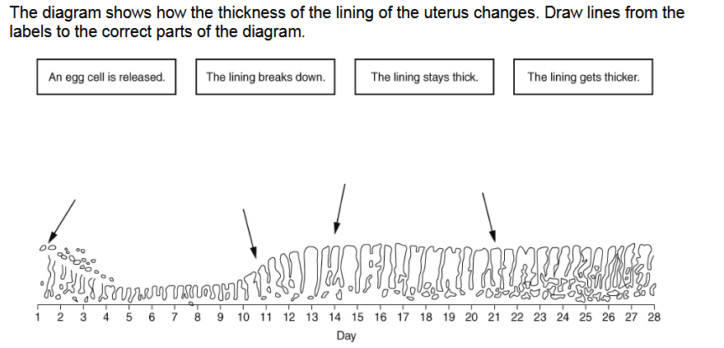
- Where are egg cells released from?__________________________________________
- What is it called when an egg cell is released?__________________________________
- What is produced when a sperm cell fuses with an egg cell?_______________________
- How long after the start of a ‘period’ is fertilisation most likely to occur?_____________

Question 4:
