
Rosary School – Marj Elhamam
7E - Worksheet 4
Name: _________________  Grade: 6 (A,B,C,D,E) |  | Date: / / 2024
Question one: There are six questions. For each question, there are three possible answers a, b and c. Choose the one you consider correct.
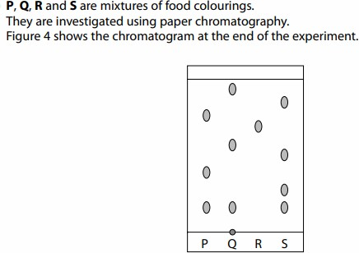
Figure 4
Answer questions 1 and 2 based on the previous figure.
- Which mixture contains an insoluble food colouring?
  - Mixture S B. Mixture R C. Mixture Q
- Which mixture has 3 food colouring mixed together?
  - Mixture P B. Mixture R C. Mixture Q
- How many spots are produced on the chromatogram of a pure substance?
B. One B. Two C. Three
Question two:
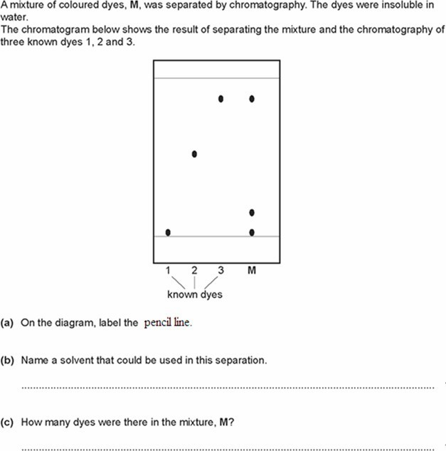
- Which of the dyes, 1, 2 & 3.were in the coloured dyes M?
……………………………………………………………………………………..…..
- What are your conclusions about the identity of the dyes in the mixture, M?
…………………………………………………………………………………………
………………………………………………………………………………………… .………………………………………...…………………………………..………….
Question three:
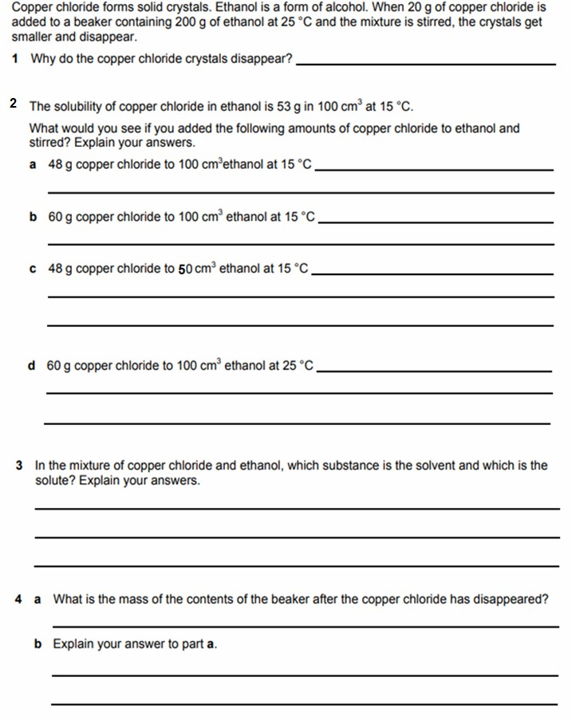
Question four:
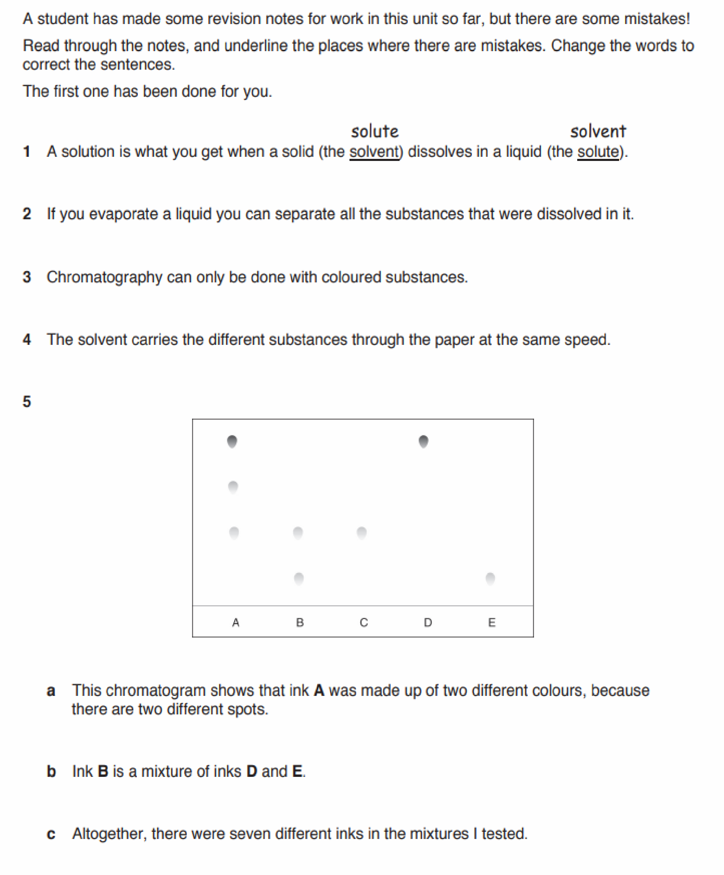
Teachers: Saja Ammari, Fadia Abu Edam, Linda Barakat

1

