

Rosary School – Marj Elhamam

Name: _________________ |  | Date: ____ /____ / 2025
Grade: 6 (A,B,C,D,E) |  | Subject : Science
7F Worksheet 5
Q1: Phenolphthalein is an indicator that has a different colour in acids and alkalis.
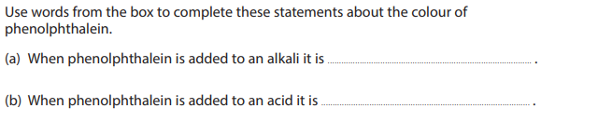

Q2: Circle the correct letter for the following question.
1- Universal indicator is added to a solution. The solution turns purple. The solution contains:
A) citric acid. B) hydrochloric acid.
C) sodium hydroxide solution. D) only water.

Q3: Concentrated sulfuric acid is labelled with a corrosive hazard symbol. Describe what you would have to do the acid so that it can be labelled with an irritant hazard symbol.
___________________________________________________________________
Q4: Explain why diluting an acid reduces the hazard.
__________________________________________________________________________

Q5: A farmer measures the pH value of the soil in four different fields A, B, C and D. The table shows the results.
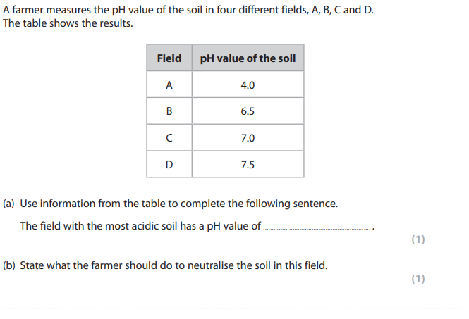

Q6: Complete the word equations below for the reactions of acids with alkalis or bases.
- hydrochloric acid + sodium hydroxide → _________________+ water
- sulfuric acid + _______________→ magnesium sulfate+ _________
- nitric acid + zinc oxide →________________ + water
- ________________ + ________________ → potassium chloride + water
- sulfuric acid + calcium hydroxide→ __________________ + water
- ______________+ ____________________→ sodium nitrate + water

Q7: What kind of substances should always be heated in a water bath, rather than by a Bunsen burner?
__________________________________________________________________________

Q8:
