Worksheet 6

Rosary School / Marj El Hamam
Name : _____________________ Date : / 2 / 2025
Subject :Science Grade: 6 ( )
Question 1:
The properties of materials can be explained using particle theory.
Brownian motion provides evidence to support particle theory.
a) Give an example of Brownian motion. _______________________________________
b) Explain how Brownian motion supports the idea that matter is made from tiny
Particles in random movements.
____________________________________________________________________
____________________________________________________________________
____________________________________________________________________
Question 2:
(a) The diagrams, X, Y and Z, show how the particles are arranged in the three states of matter.
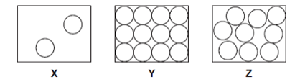
(i) Which one of the diagrams, X, Y or Z, shows the arrangment of particles in aliquid?
Write the correct answer in the blank. ________________
(ii) Which one of the diagrams X, Y, or Z, shows the arrangment of particles in a gas? Write the correct answer in the blank._____________
(b) Draw a ring around the correct answer in each box to complete each sentence.
(i) In gas, the particles are (vibrating in fixed positions/ moving randomly/not moving).
(ii) In a solid, the forces between the particles are(stronger than/ equal to/ weaker than) the forces between the particles in a liquid.
Question 3:
Explain why is it difficult to suck up water from a glass if there is a hole in the straw above the water level?
____________________________________________________________________________________________________________________________________________________________________________________________________________
Question 4:
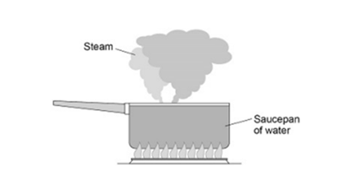
(a) Complete the sentences.
Choose answers from the box.
Each answer may be used once, more than once or not at all.
The distance between the particles in steam is _____________ the distance between the particles in liquid water.
The density if steam is _____________ the density of liquid water.

Question 5:
A Students investigated how the pressure of gas varied with the volume of the gas.
The mass and temperature of the gas were constant.
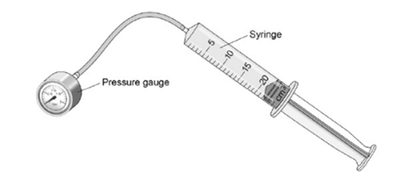
Complete the sentences.
Choose the answers from the box.
Each answer may be used once, more than once or not at all.
When the gas is compressed, the volume of gas in the syringe _____________.
So the number of collisions each second between the gas particles inside the syringe and the inside surface of the syringe ____________________.
This means the force exerted on the inside surface of the container walls_______________.

Question 6:
The figure below shows a party balloon, filled with air.
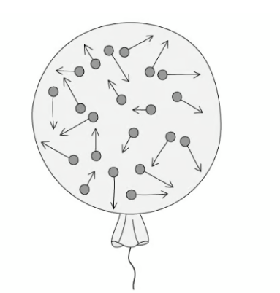
- Describe the motion of the air particles inside the balloon.
________________________________________________________________________________________________________________________________________
- Explain in terms of particles why the air inside the balloon can be easily compressed.
________________________________________________________________________________________________________________________________________

