
Rosary School – Marj Elhamam
Worksheet (7)
Name: |  | Date: / / 2025
Grade: 7 (A,B,C,D,E) |  | Subject: Chemistry

Question one:
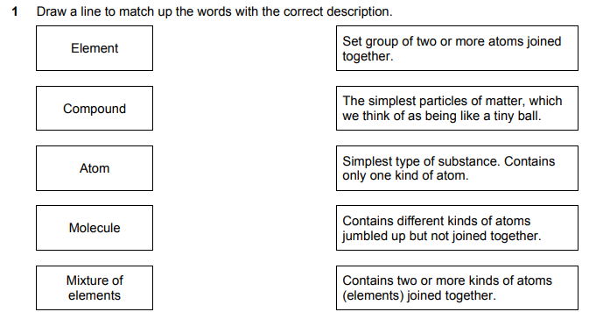
Question two:
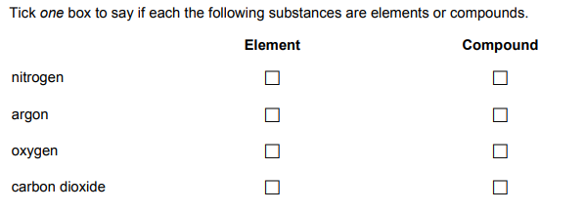

Question three:
For each diagram choose one of the following terms that best describes the model shown.
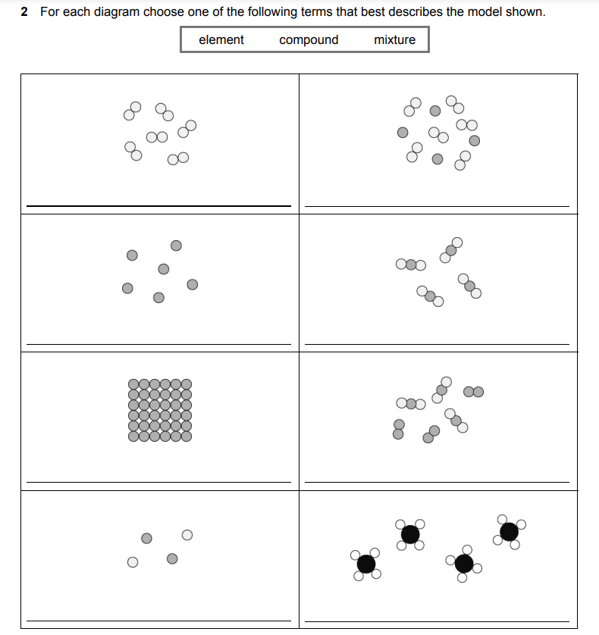

Question four:
Write the word ‘atoms’ or ‘molecules’ below the correct diagrams. Explain your answer.

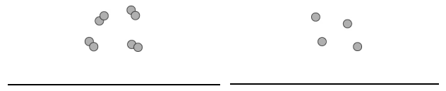

Question five:
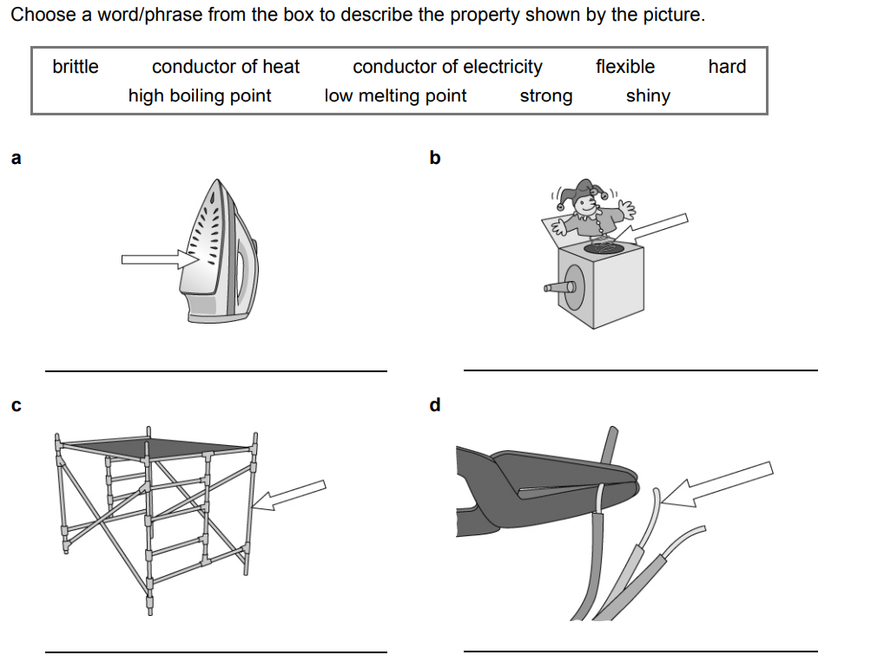

Question six:
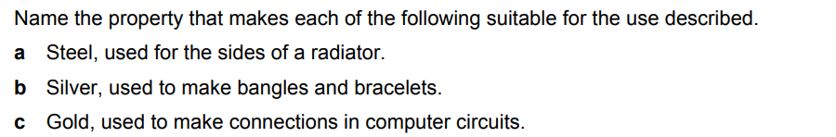

Question seven:
