 |   Rosary School – Marj Elhamam  7L - Physics Worksheet 10 | 
Name: __________________ Date: / / 2024
Grade: 7 (A,B,C,D)

Question 1:
The diagram shows a simple wave.
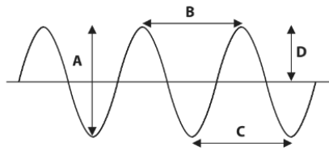
Which arrow, A, B, C or D, shows the particle movement? ______________

Question 2:
Ultrasound waves are used to produce images.
This is an ultrasound image for a fetus surrounded by fluid.
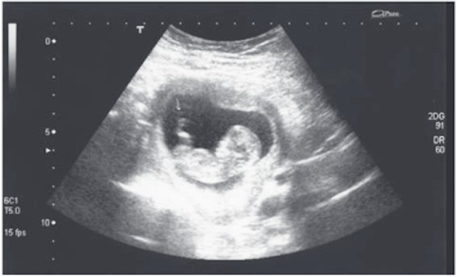
- The ultrasound wave is caused by waves bounce off the fetus.
This is an example of waves that are.
absorbed

reflected
refracted
transmitted

2) Describe two other uses of ultrasounds.
i) _______________________________________________________________________
ii) _______________________________________________________________________

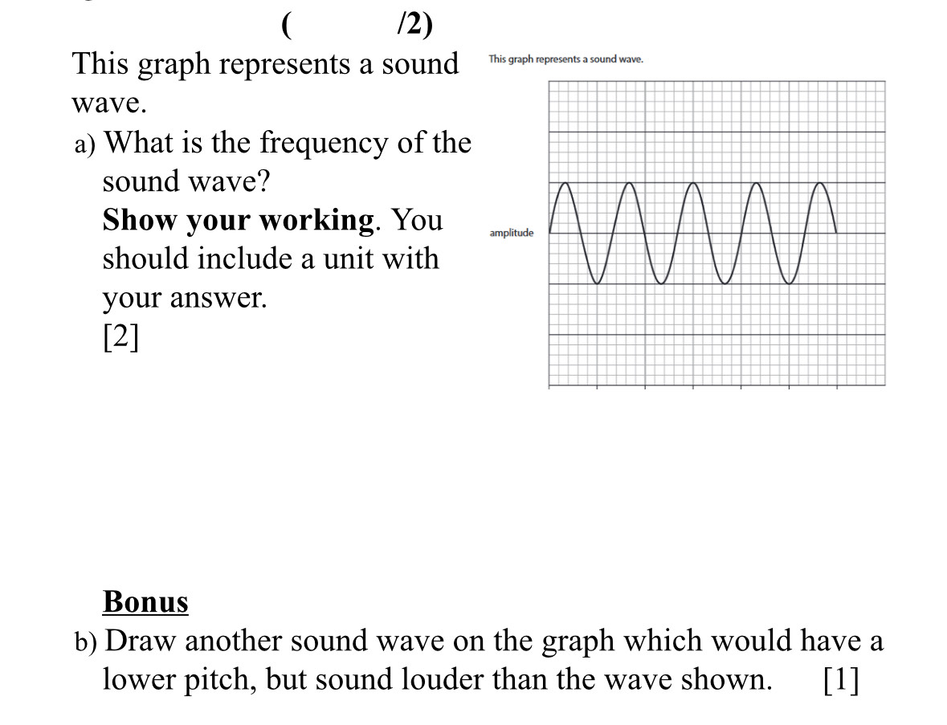
Question 3:
This graph represents a sound wave.
- What is the frequency of the sound wave?
Show your working. You should include units with your answer.

- Draw another wave on the graph which would have a lower pitch, but sound louder than the wave shown.

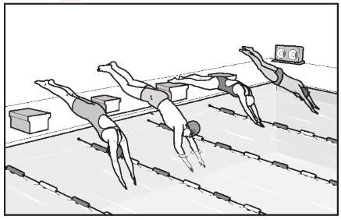
Question 4:
Four swimmers are competing at a swimming pool.
The figure shows the swimmers starting a race.
- The swimmers start the race when they hear the starting sound from a loudspeaker.
State whether each of the following is an example of a transverse wave or a longitudinal wave.
The sound wave produced by the loudspeaker: ________________________
The water wave produced by the swimmers in the swimming pool: __________________

- One of the water waves on the surface of the swimming pool is shown in the figure.

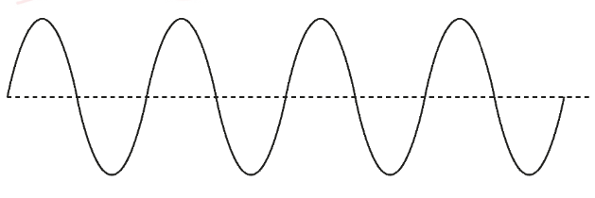
On the figure, mark with a double headed arrow ( ) one amplitude.

Question 5:
The following table shows the audible frequency range of five animals.
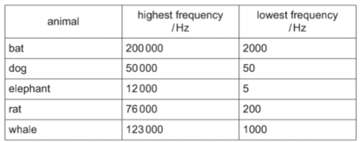

  - State which animal in the table can hear a sound with the highest pitch.
________________________________________________________________
  - State which animal in the table can hear infrasound.
________________________________________________________________
  - State the audible frequency range for a human.
from ______________________ to ________________________

Question 6:
A police car siren emits two different sounds P and Q. These are produced alternately (one after the other). The diagram represents the sounds emitted.
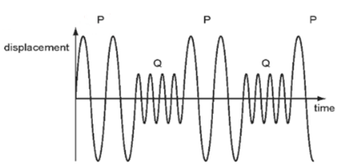
Which sound is louder and which has the lower pitch?
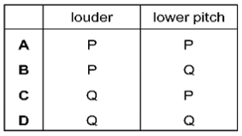

Question 7:
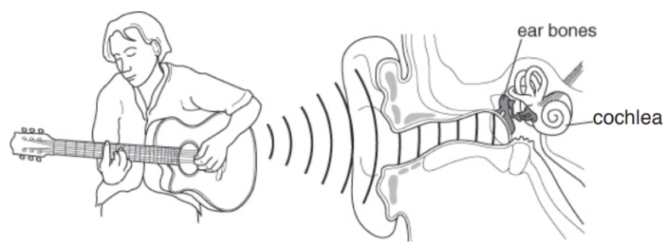
The diagram below shows someone playing a guitar and shows part of an ear. The eardrum vibrates when sound waves reach it.

a. Give the function of:
- the ear bones: ____________________________________________________________
- the cochlea: _____________________________________________________________

- What happens to the eardrum if the sound reaching the ear gets louder?
- the eardrum vibrates faster
- the eardrum vibrates slower
- the eardrum vibrates further
- the eardrum vibrates less
Question 8:
The diagram shows a bat using ultrasound waves to detect a bird in the dark.
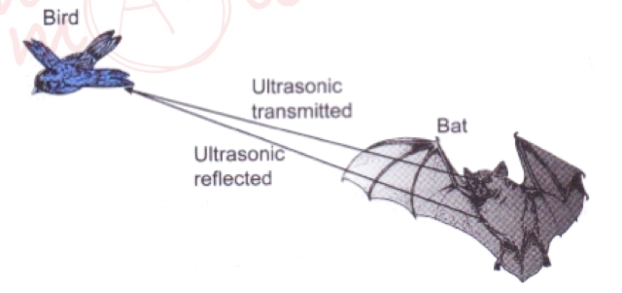
i) The name of the process the bat uses to detect the bird is. ________________.
ii) Explain how the bat uses the ultrasound waves to determine the distance of the bird from it.
__________________________________________________________________________________________________________________________________________________________________.

Teacher: Saja Ammari

