 |   Rosary School – Marj Elhamam  Worksheet 1 | 
Name: _________________ |  | Date: / / 2024
Grade: 6 (A,B,C,D,E)
Question 1:
Choose the correct answer.

1) What are all living things called?
A) animals B) bacteria
C) organisms D) nutrition

2) An organ found in plants is the:
A) stem. B) stomach.
C) xylem. D) soil.

3) Which ‘life process’ is involved when a mouse smells cheese?
A) excretion B) sensitivity
C) reproduction D) respiration

4) Which life process are the kidneys used for?
A) sensitivity B) respiration
C) excretion D) growth

5) Your heart is made of:
A) food. B) skin.
C) fat and muscle. D) blood.

6) Roots and leaves both contain:
A) xylem. B) root hairs.
C) soil. D) nerves.

Question 2:
The Diagram shows some of the organs in the human body.

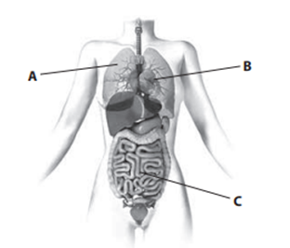
- The table gives the names and functions of the organs labelled in the diagram.
Complete the table.
Letter | Name of organ | Function of organ
A | Hr Lungs | takes in oxygen and removes carbon dioxide
B | Heart | Pump blood around the body
C | Small intestines | G 1. Absorb nutrients 2. Breaks up food  2
- Suggest two organs involved in the digestion of your food and describe the function of each organ.
Stomach ----- breaks up food
Small intestines ---- breaks up food and absorbs it
Question 3:
The diagram shows a growing plant.
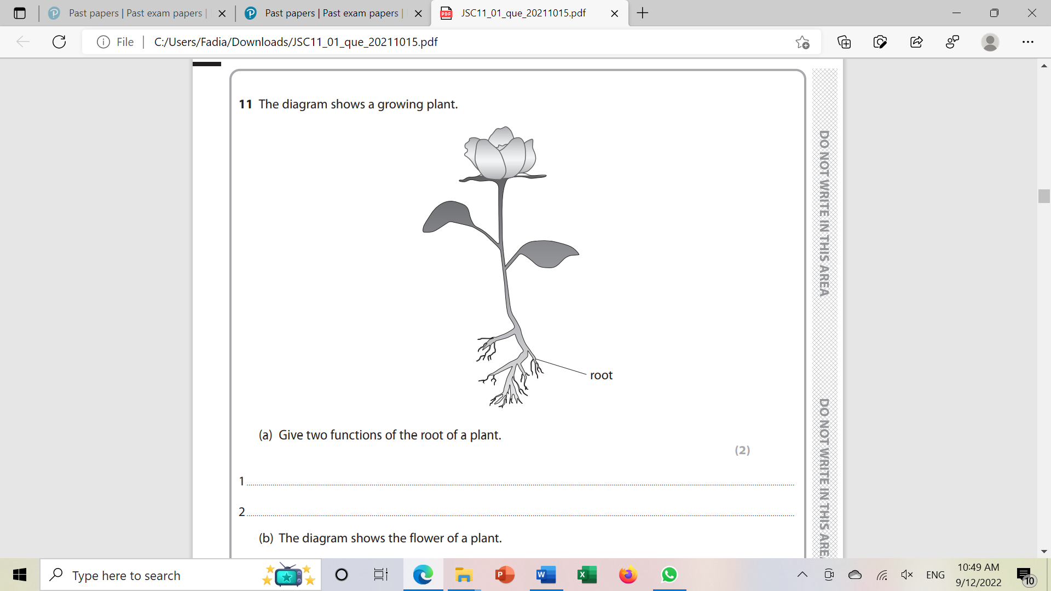

- Name in order, the organs water passes through when traveling through a plant.
Root, stem, leaves
- Water travels through specialised cells called xylem cells. Give the general name we use for a group off cells that work together to do the same job.
Tissue
- Name two other specialised plant cells and describe their functions.
Root hair tissue ---- absorb water from soil
Phloem ---- transport food from leaves to roots
Question 4:
The diagram below shows a section through a rat. Some of the rat’s organs have been labelled.
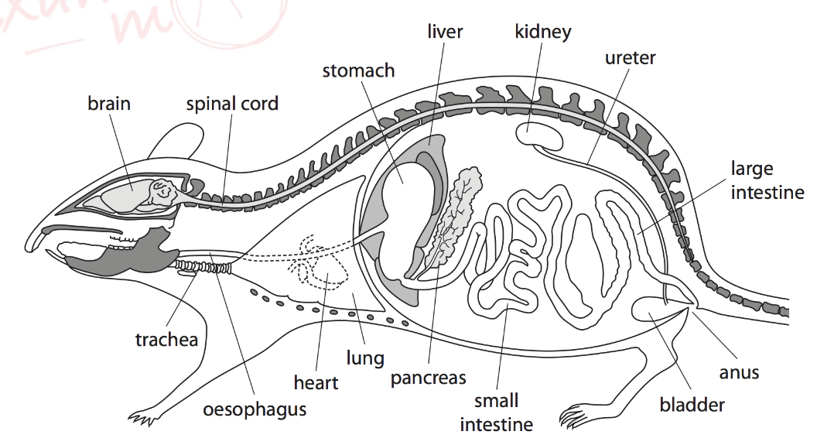
(i) What is meant by the term organ system?
A group of organs working together
(ii) Name the organ labelled on the diagram that is part of the circulatory system.
Heart
(iii) Name three organ systems shown in the diagram and their functions.
- Urinary system --- excretion
- Circulatory system --- to carry nutrients/ food/ waste/ around the body
- Digestive system --- Nutrition
- Breathing/ respiratory/ ventilation ---- takes in Oxygen and removes Carbon dioxide
(iv) Name a system that is not shown in the diagram.
Locomotor system
Question 5:
The diagram below shows a plant cell.
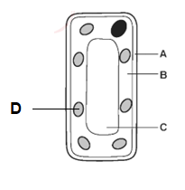
- Name the three parts of the cell labelled A,B and C.
A Cell wall
B Cytoplasm
C Vacuole

- Which labeled part cannot be found in the root hair cell? Explain your answer
(D) Chloroplast, there is no light underground, chloroplasts make food for the plants using photosynthesis
- In the table below tick boxes to show which parts are present in both animal and plant cells.
Cell wall
Cell surface membrane | 
Vacuole
Nucleus
Cytoplasm
Chloroplast
Mitochondria

Teachers:
Saja Ammari, Linda Barakat, Fadia Abu Edam

