
Rosary School – Marj Elhamam
Worksheet 9
_{Name: _________________} Date: ____ /____ / 2025 Grade: 6( A,B,C,D,E ) Subject : Science

Question 1:
Jamila and Tia investigate friction. Jamila sits on a sheet of material. She moves down the slide on the material.
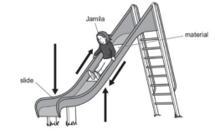
(a) The arrows on the diagram show the different forces acting on Jamila as she moves down the slide
Circle the arrow on the diagram that shows friction
(b)Tia records the time it takes Jamila to move down the slide on different materials.
Here are their results.
Material | Time taken to move down the slide in seconds
A | 2
B | 5
C | 1
D | 2
E | 3

Which material has the most friction? Explain your answer.
B, it took the longest time to move down the slide, friction slows down
objects.
Question 2:
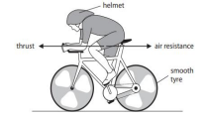
The diagram shows two forces acting on a
cyclist moving along a racing track.
The arrows in the diagram show the size and
direction of the two forces.
a) Explain how will the speed of the cyclist
change due to the forces acting on her.
The cyclist will speed up, because thrust is greater than air resistance. The greater force is acting into the direction of movement
b) During wet conditions the racing track becomes very slippery. State a change the cyclist could make to the bicycle to overcome the wet conditions.
Increase the friction by changing the tyres to have better grooves
Question 3:
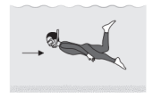
The diagram shows a person swimming
underwater.
What force does the arrow represent?
Water resistance
Question 4:
There are many different types of forces.
(a) Ryan uses a rope to climb down the side of a mountain.
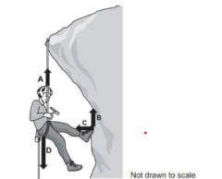
a) Which arrows A, B, C, or D represents the force of gravity acting on Ryan? D
b) Name one other force acting on the Ryan as he climbs the mountain. A: Applied force of rope holding Ryan
B: Friction between cliff and foot
C: Normal force between cliff and foot
c) What scientific unit are forces measured in? Newton (N) d) Which of the forces acting on Ryan is a non-contact force? Gravitational force .
Question 5:
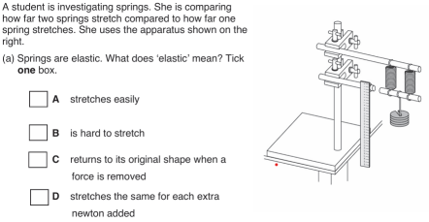
(b)Give one factor the student must keep the same to make the test fair. The same weight added each time/ same ruler
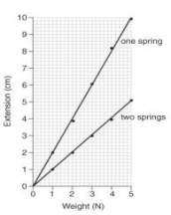
(c) Describe one safety precaution the student should
take.
Fix the apparatus in position for it not to fall
(d)The graph shows the results from the investigation.
From the graph write a conclusion for the investigation.
The extension of two springs is smaller than the extension
of one spring when adding the same weight
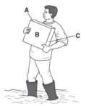
Question 6:
A man is working in a muddy garden. When he picks up a
paving stone his feet sink deeper into the mud.
a) Explain why his feet sink into the mud when he picks up
the paving stone. Write about pressure in your answer.
Because the force increased, so the pressure under his feet increases for the same surface area.
b) The paving stone has a weight of 600 N. Side A has an area of 300 cm². Calculate the pressure under the paving stone if the man puts the stone on side A.
P = F÷ A
= 600÷ 300
= 2 N/cm2
Question 7:
a) A woman is applying 300 N/m²of pressure onto a door with her hand. Her hand has area 0.02m². Calculate force being applied.
F=P*A
= 300*0.02
= 6N
b) A force of 600N is applied to a square of side length 300cm. Calculate the pressure on the square in Pascal.
to convert from cm to m we divide by 100
300÷ 100 = 3m
A = L*W , A = 3*3 = 9 m²
P = F ÷ A
= 600 ÷ 9
= 66.6 Pa
Question 8:
The car is moving
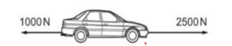
(a) State whether the forces are balanced or unbalanced?
Unbalanced
(b) What will happen to the speed of the car?
It will increase (accelerate)

