

Rosary School – Marj Elhamam
Worksheet 2
Name: _________________ |  | Date: / / 2025
Grade: 6 (A,B,C,D,E) |  | science
Question 1:
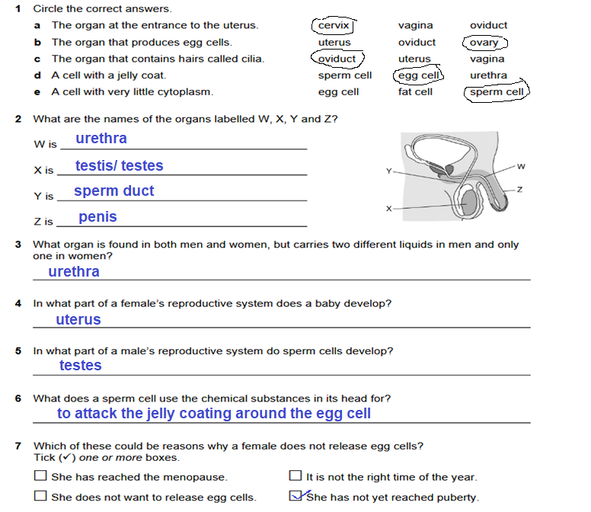
Question 2 :
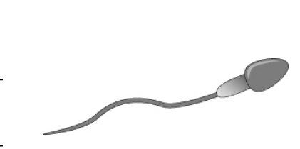
The drawing shows a gamete.
- Is this gamete produced by male or female?_male
- In which organs is it produced? testes
- Mention three adaptations does the gamete have.
Tail to help it to swim
Chemicals at its head(tip) that can attack jelly coating in the egg cell
Streamlined shape

Question 3:
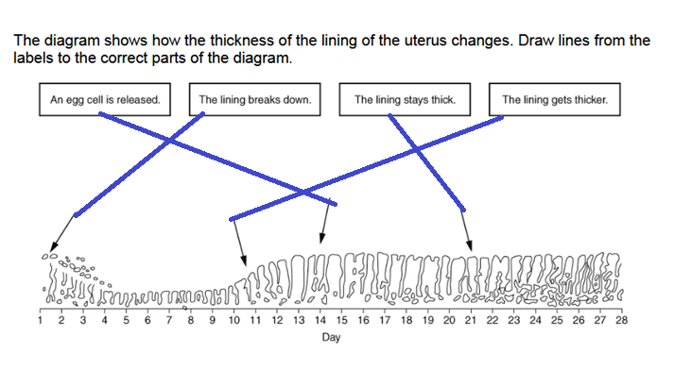
- Where are egg cells released from? ovary
- What is it called when an egg cell is released? ovulation
- What is produced when a sperm cell fuses with an egg cell? fertilised egg cell /zygote
- How long after the start of a ‘period’ is fertilisation most likely to occur? 11 -17 days
Question 4:
